

**UNIVERSITY OF PETROLEUM & ENERGY STUDIES**

**SCHOOL OF COMPUTER SCIENCE**

***Department of Cybernetics***

**GRAPHICS AND ANIMATIONS TOOLS**

LAB FILE

SESSION(2020-21)

Course: BTech with specialization in Open Source & Open Standards

Submitted to: Submitted by:

Dr. Durgansh Sharma Mridul Thapa

Associate Professor SAP: 500060077

Department of Cybernetics Roll no: R100217*039*

**PROJECT**

3D-LIGHTING IN WORKSPACE

**Step 1:** Open Blender, Create a blank file

**Step 2:** Add a plane and scale it to an average area of a workspace, using Shift+A>S.

**Step 3:** Switch to edit mode using TAB.

**Step 4:** Add some lines, to create a 2D drawing

**Step 5:** Now we extrude (E) the drawing up to the height of an average human’s seat height.

**Step 6:** To make a triangular shape table, follow Step4 again to create a drawing.

**Step 7:** Now add thickness to the table by extrude (E) command.

**Step 8:** To create the alternative table for free space, follow step2 to create a plane and make alternative triangles as drawing.

**Step 9:** Adding width to the tables again use the extrude (E) command to make a 3D model of a working environment

**Step 10:** Now adding some lighting fixtures by selecting a plane.

**Step 11:** Draw rectangles and extrude it.

**OUTPUT SCREEN:**

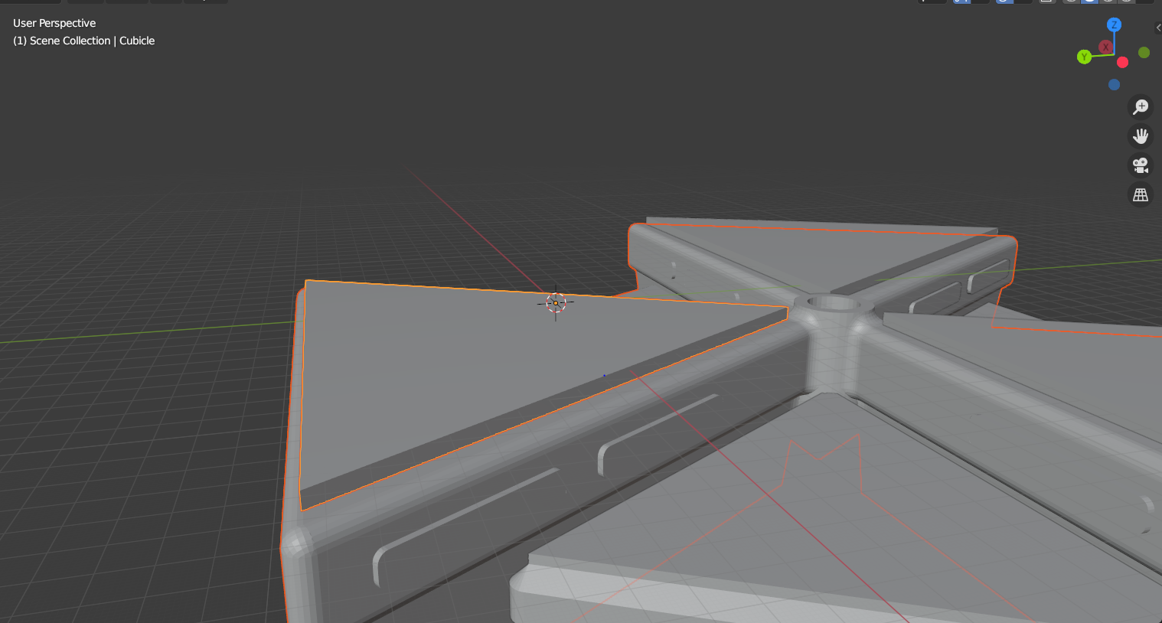

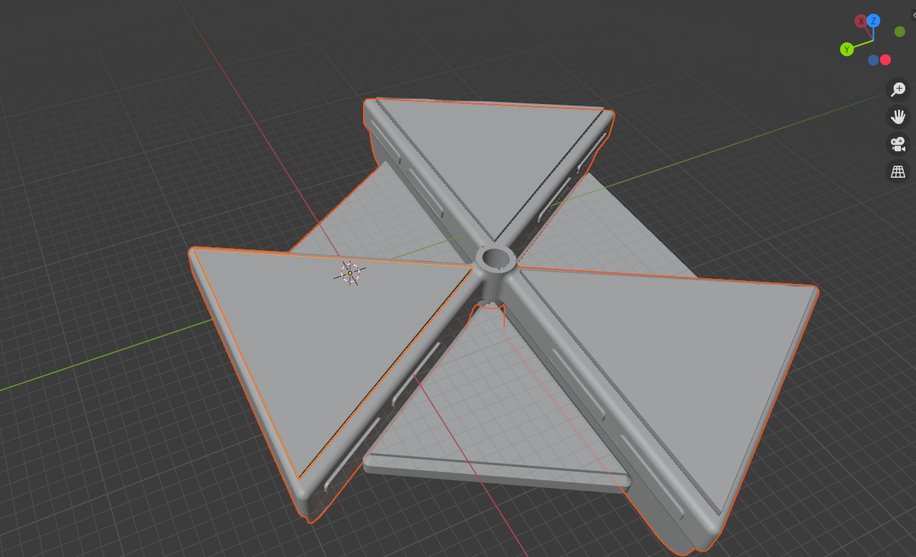

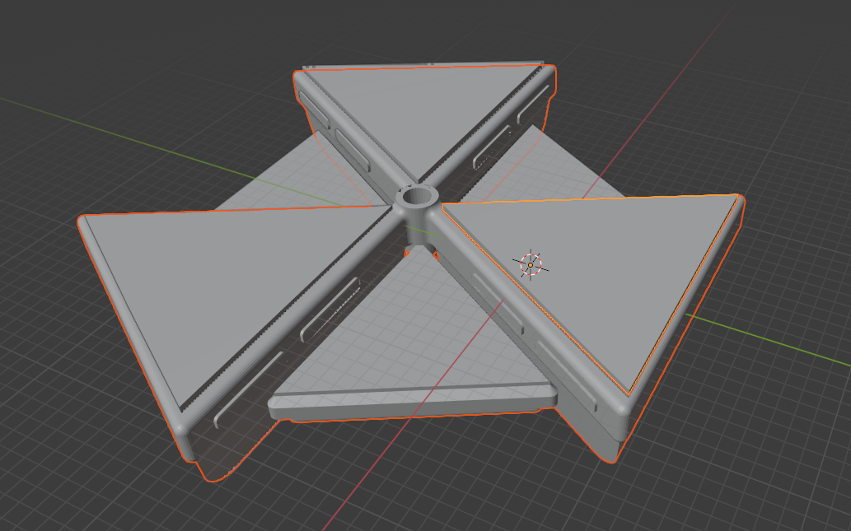

[**Link to Experiment**](https://drive.google.com/drive/folders/1flTmZIImByf3y0i2nJoYBXPXMLePEHfe?usp=sharing)